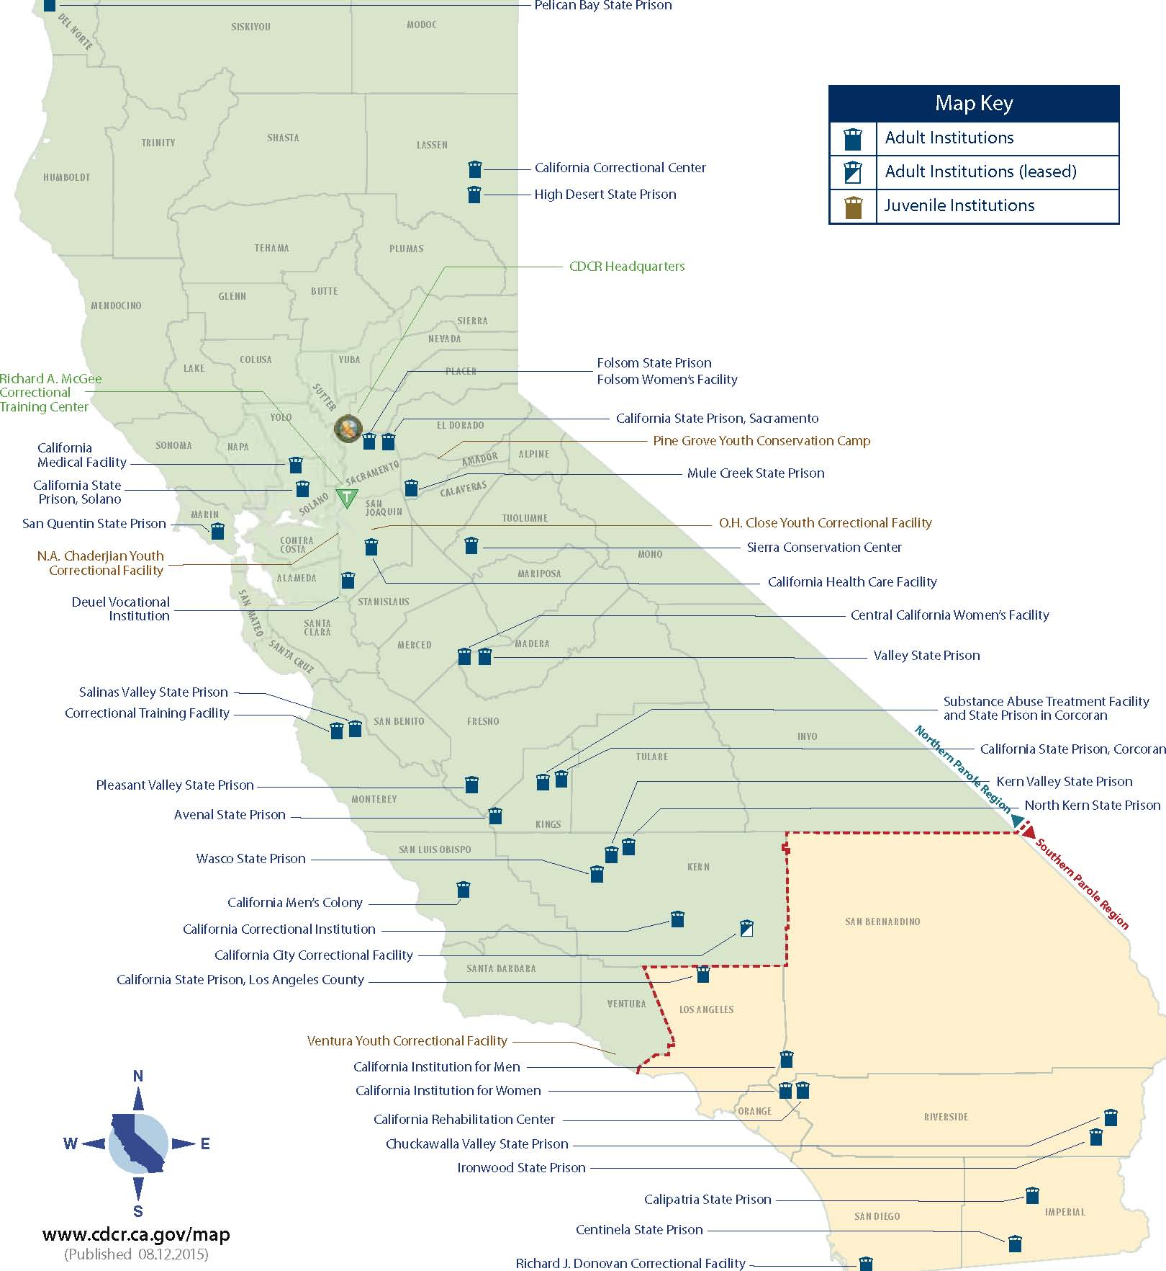
Figure 1 California map of California State Institutions and Facilities

